**Assignment 5**

Computer Networks Lab

T Satwik

**Roll no: 190030043**

**IP Address: 192.168.1.13**

**Q1. The Basic HTTP GET/response interaction.**

1. The browser is running the HTTP 1.1 version as we can see in the first line in the Hypertext Transfer Protocol section in the GET request message. The server is also using HTTP 1.1 version as we can see in the first line of Hypertext Transfer Protocol section in the response message.
2. The languages accepted are en-US, en, which means US english and english. This can be seen in the Accept-Language line in the Hypertext Transfer Protocol section in the GET request message.
3. The IP address of my computer is 192.168.1.13, as we can see in the Source Address line in the Internet Protocol Section. The IP address of gaia.cs.umass.edu server is 128.119.245.12, as we can see in the Destination Address line in the Internet Protocol Section.
4. Status Code returned by the server to the browser is 200 OK, as we can see in the first line of Hypertext Transfer Protocol section in the response message.
5. The HTML file was last modified Thu, 04 Mar 2021 06:59:01 GMT, as we can see in the Last Modified line of Hypertext Transfer Protocol section in the response message.
6. 128 bytes of data is being returned by the server to the browser, as we can see in the Content Length line of Hypertext Transfer Protocol section in the response message.
7. No, there are no headers in the packet content window that are not listed in the packet-listing window. I have attached the screenshot of the packet content window in the zip file, please refer if necessary.

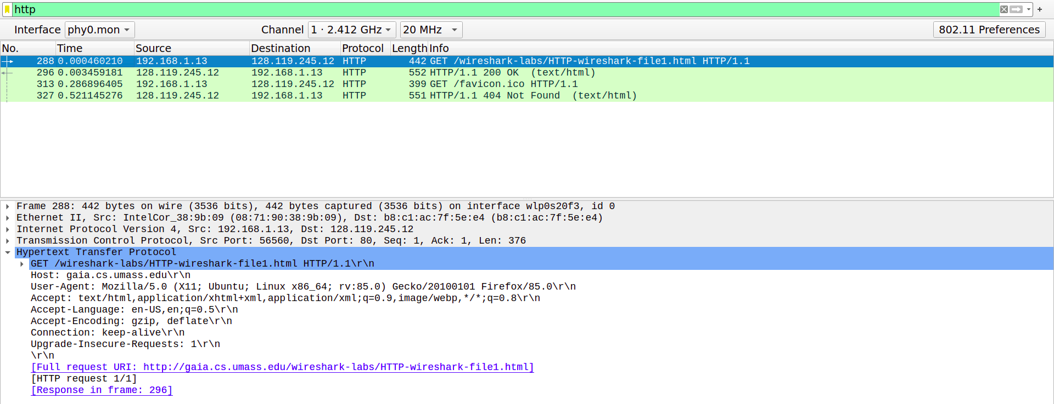

Q1 HTTP GET request

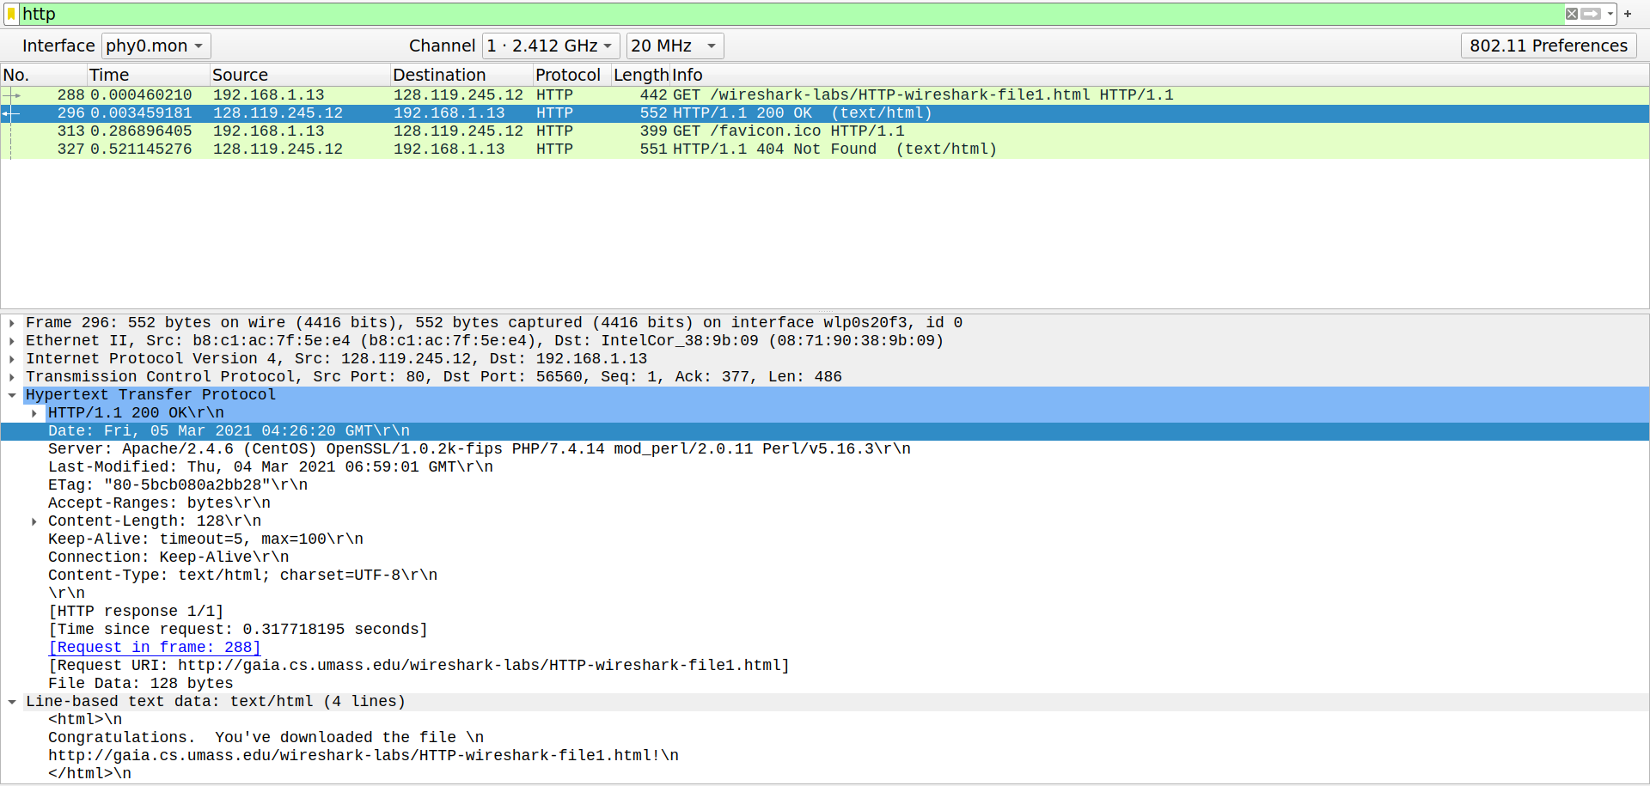

Q1 HTTP OK response

**Q2. The HTTP CONDITIONAL GET/response interaction.**

1. No, there is no “IF-MODIFIED-SINCE” line in the first HTTP GET request packet.
2. Yes, the server explicitly returned the contents of the file to the browser, as the Line-based text data section in the response message shows the whole content of the html file.
3. Yes, there is a “IF-MODIFIED-SINCE” line in the second HTTP GET request packet. The information that follows is the date and time at which the browser first downloaded the resource, in my case the value was Thu, 04 Mar 2021 06:59:01 GMT.
4. The HTTP status code and phrase returned from the server in response to this second HTTP GET is 304 Not Modified. The server didn’t return the content explicitly, as there is no Line-based text data section. Since the webpage is not modified, the browser displays the previously downloaded web page from the cache.

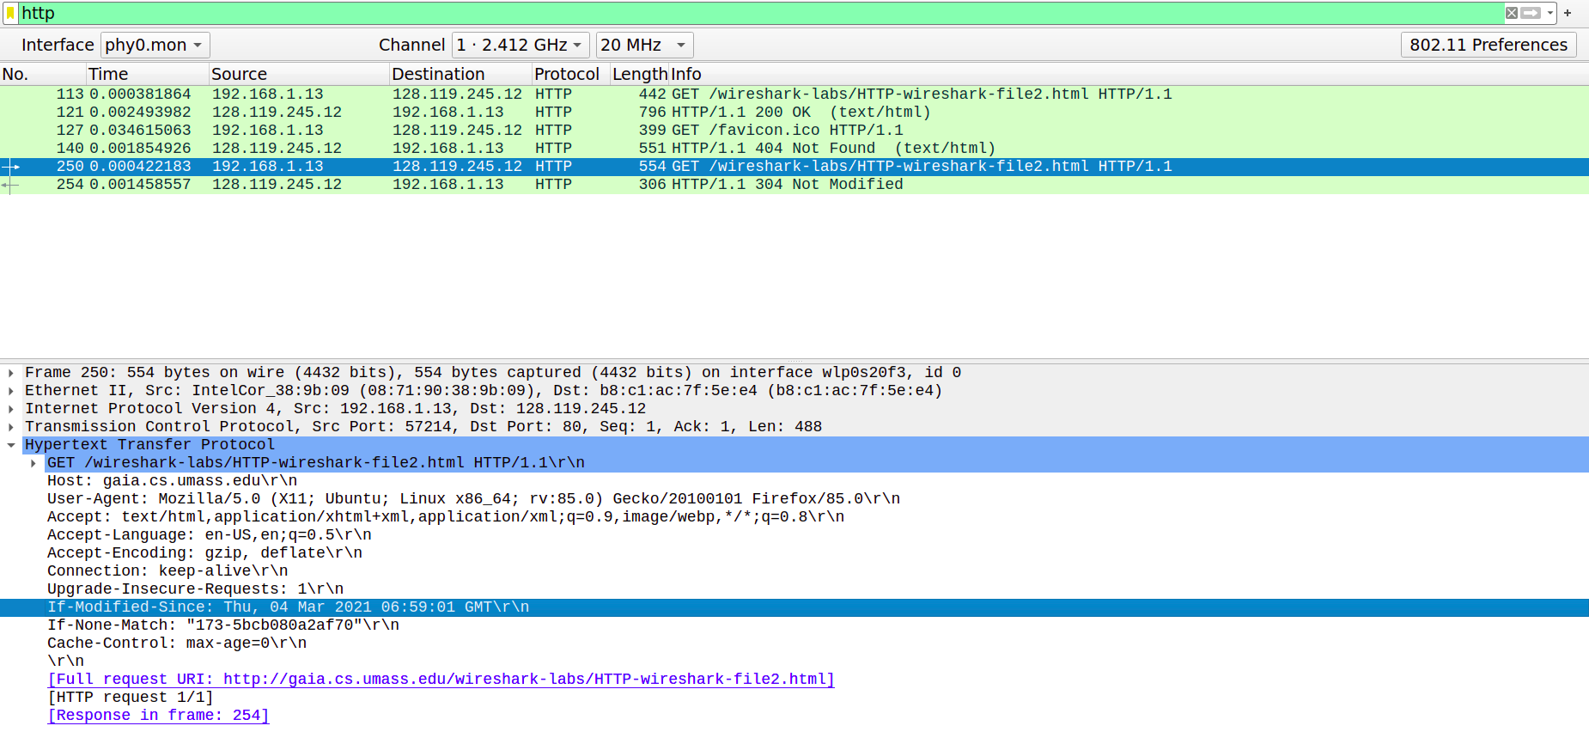

Q2 Second GET request

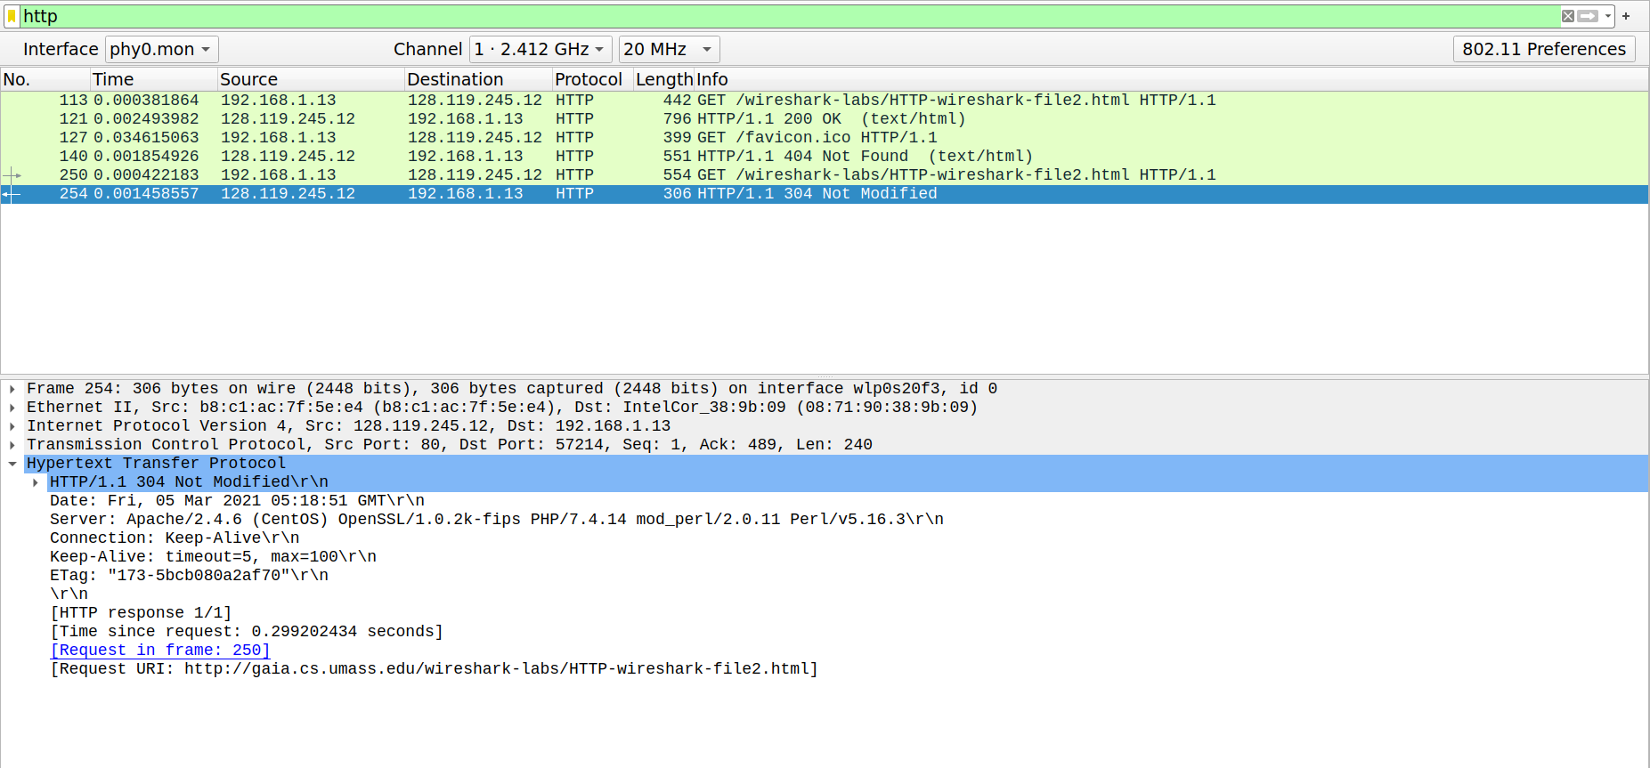

Q2 Response to the second GET request

**Q3. Retrieving Long Documents**

1. Only 1 HTTP GET request message(If we consider favicon packets then there are 2 packets) was sent from my browser. Packet number 103 in the trace contains the GET message for the Bill or Rights.
2. Packet Number of the response(OK packet) to the HTTP GET request is 110.
3. The status code and phrase associated are 200 OK.
4. 2 data-containing TCP segments were needed to carry the single HTTP response and the text of the Bill of Rights, as we can see in the 2 reassembled TCP segments section and the size of segments are 2880 bytes and 1981 bytes(total=4861bytes).

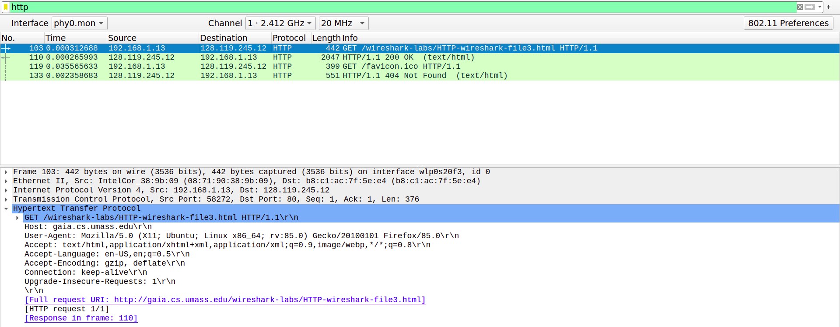

Q3 GET request

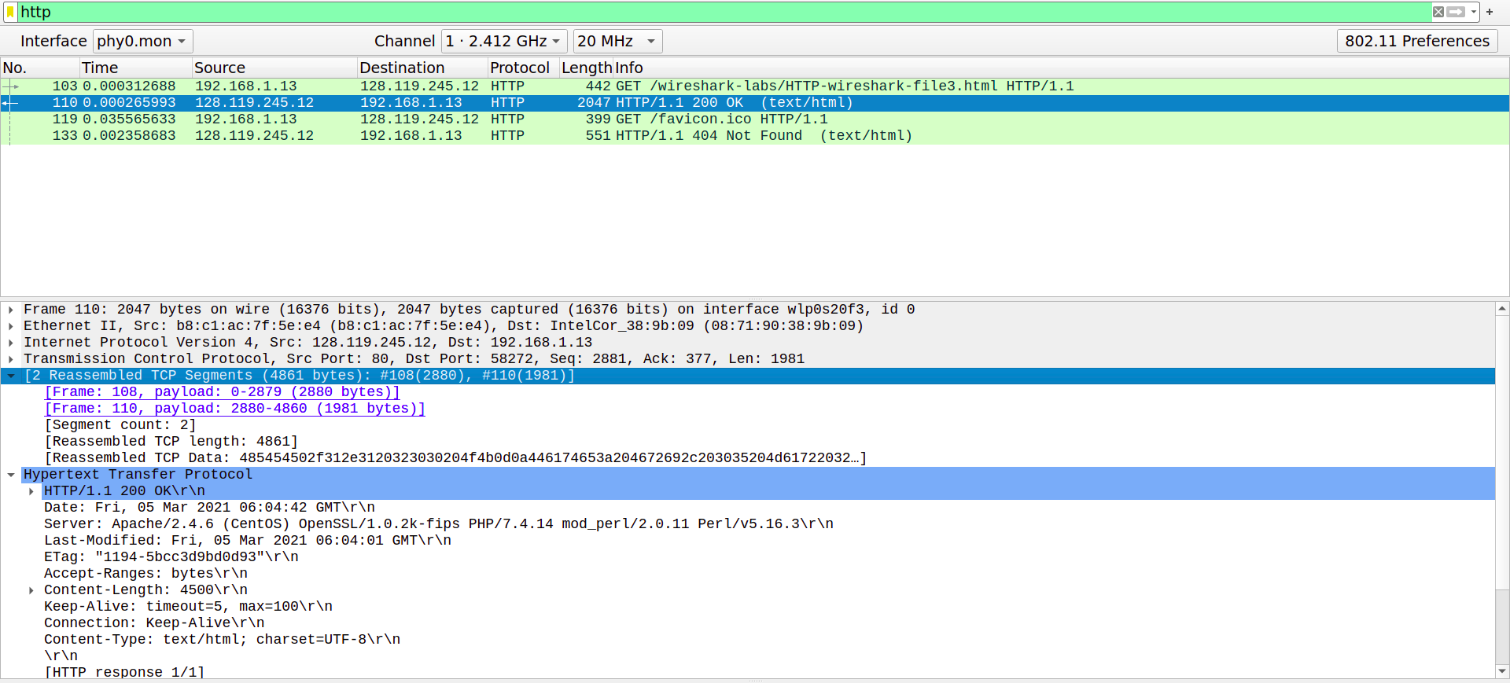

Q3 Response

**Q4. HTML Documents with Embedded Objects.**

1. 3 HTTP GET request messages(If we consider favicon packets then there are 4 HTTP request packets) were sent from the browser. 1 for the web page and 2 for the images. The HTTP webpage and the pearson image were sent to 128.119.245.12 and the 8E small cover image request was sent to 178.79.137.164.
2. The 2 images were downloaded serially, one after the other. The GET request for the first message was sent and the OK message was received, then the GET request for the second image was sent to 178.79.137.164, and a response message was received. Hence they are downloaded serially.

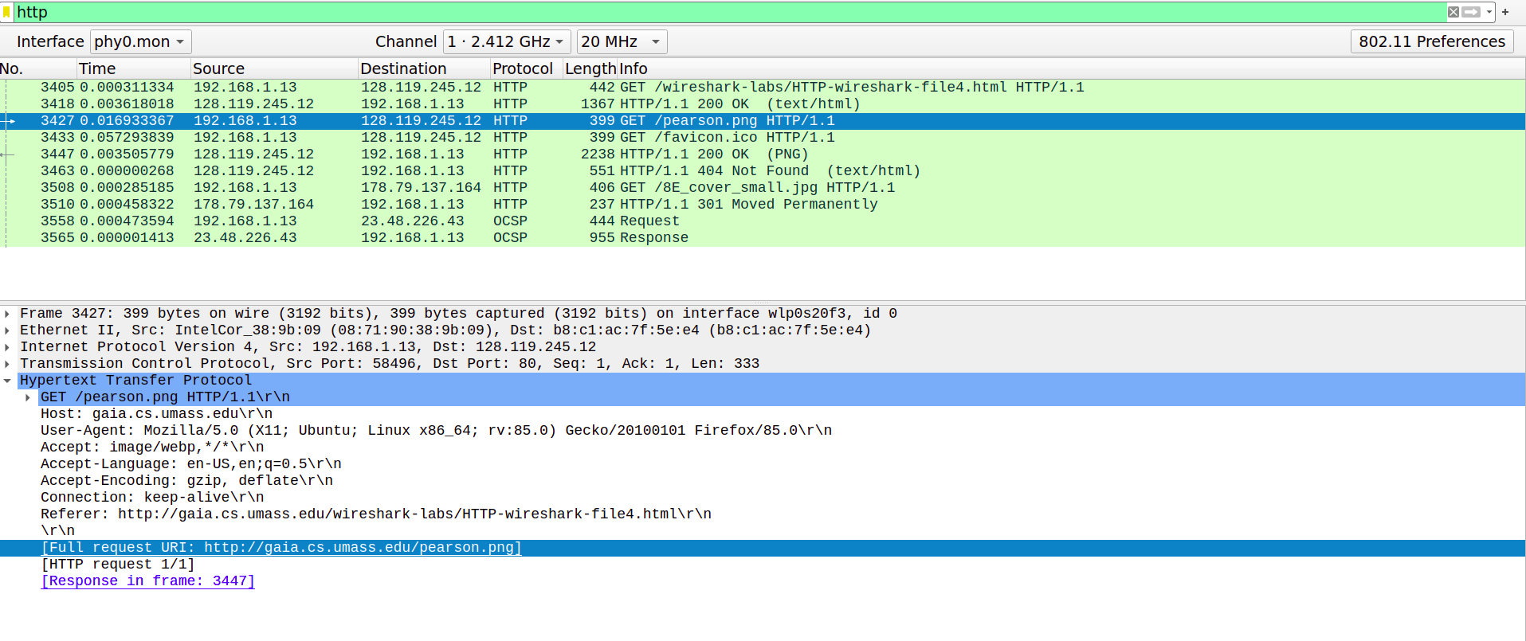

Q4 first Image GET request

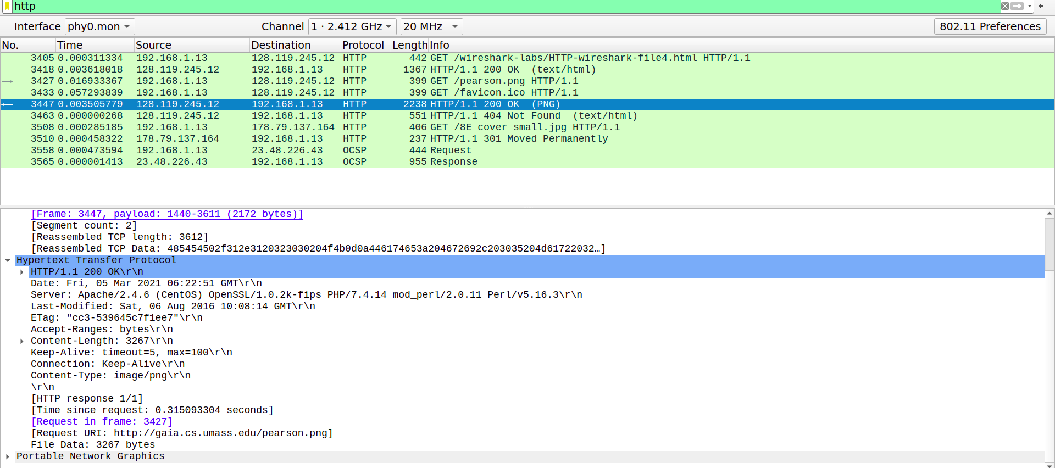

Q4 first Image response

**Q5. HTTP Authentication.**

1. The server’s response (status code and phrase) in response to the initial HTTP GET message from my browser is 401 Unauthorized.
2. When your browser sends the HTTP GET message for the second time, the Authorization field is newly included in the HTTP GET message. Its value is Basic d2lyZXNoYXJrLXN0dWRlbnRzOm5ldHdvcms= which is the encrypted form of the username and password.

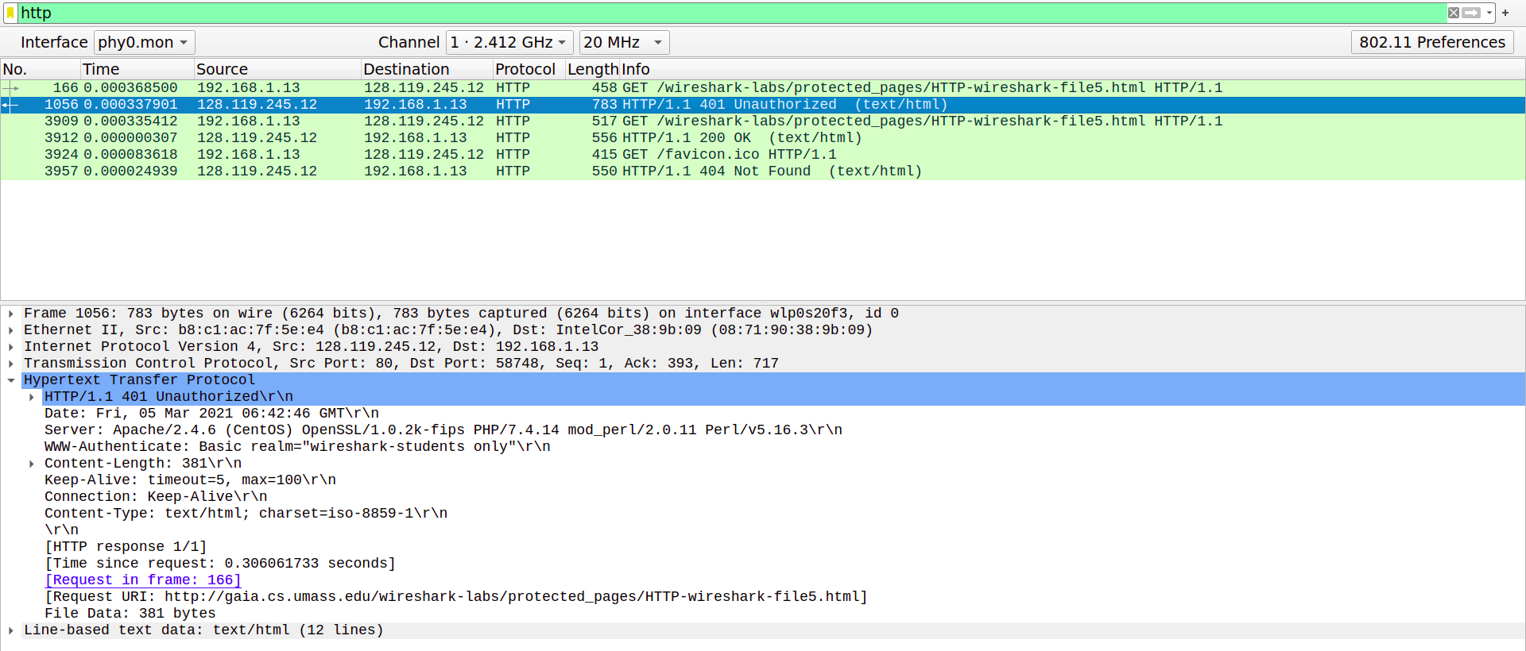

Q5 Initial Response Message

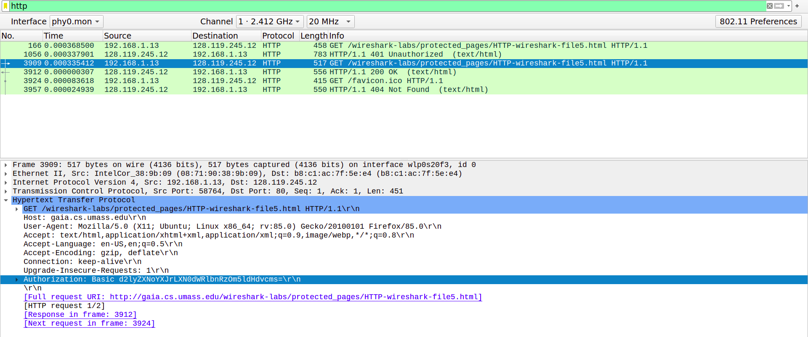

Q5 Second Get Message with authorization field